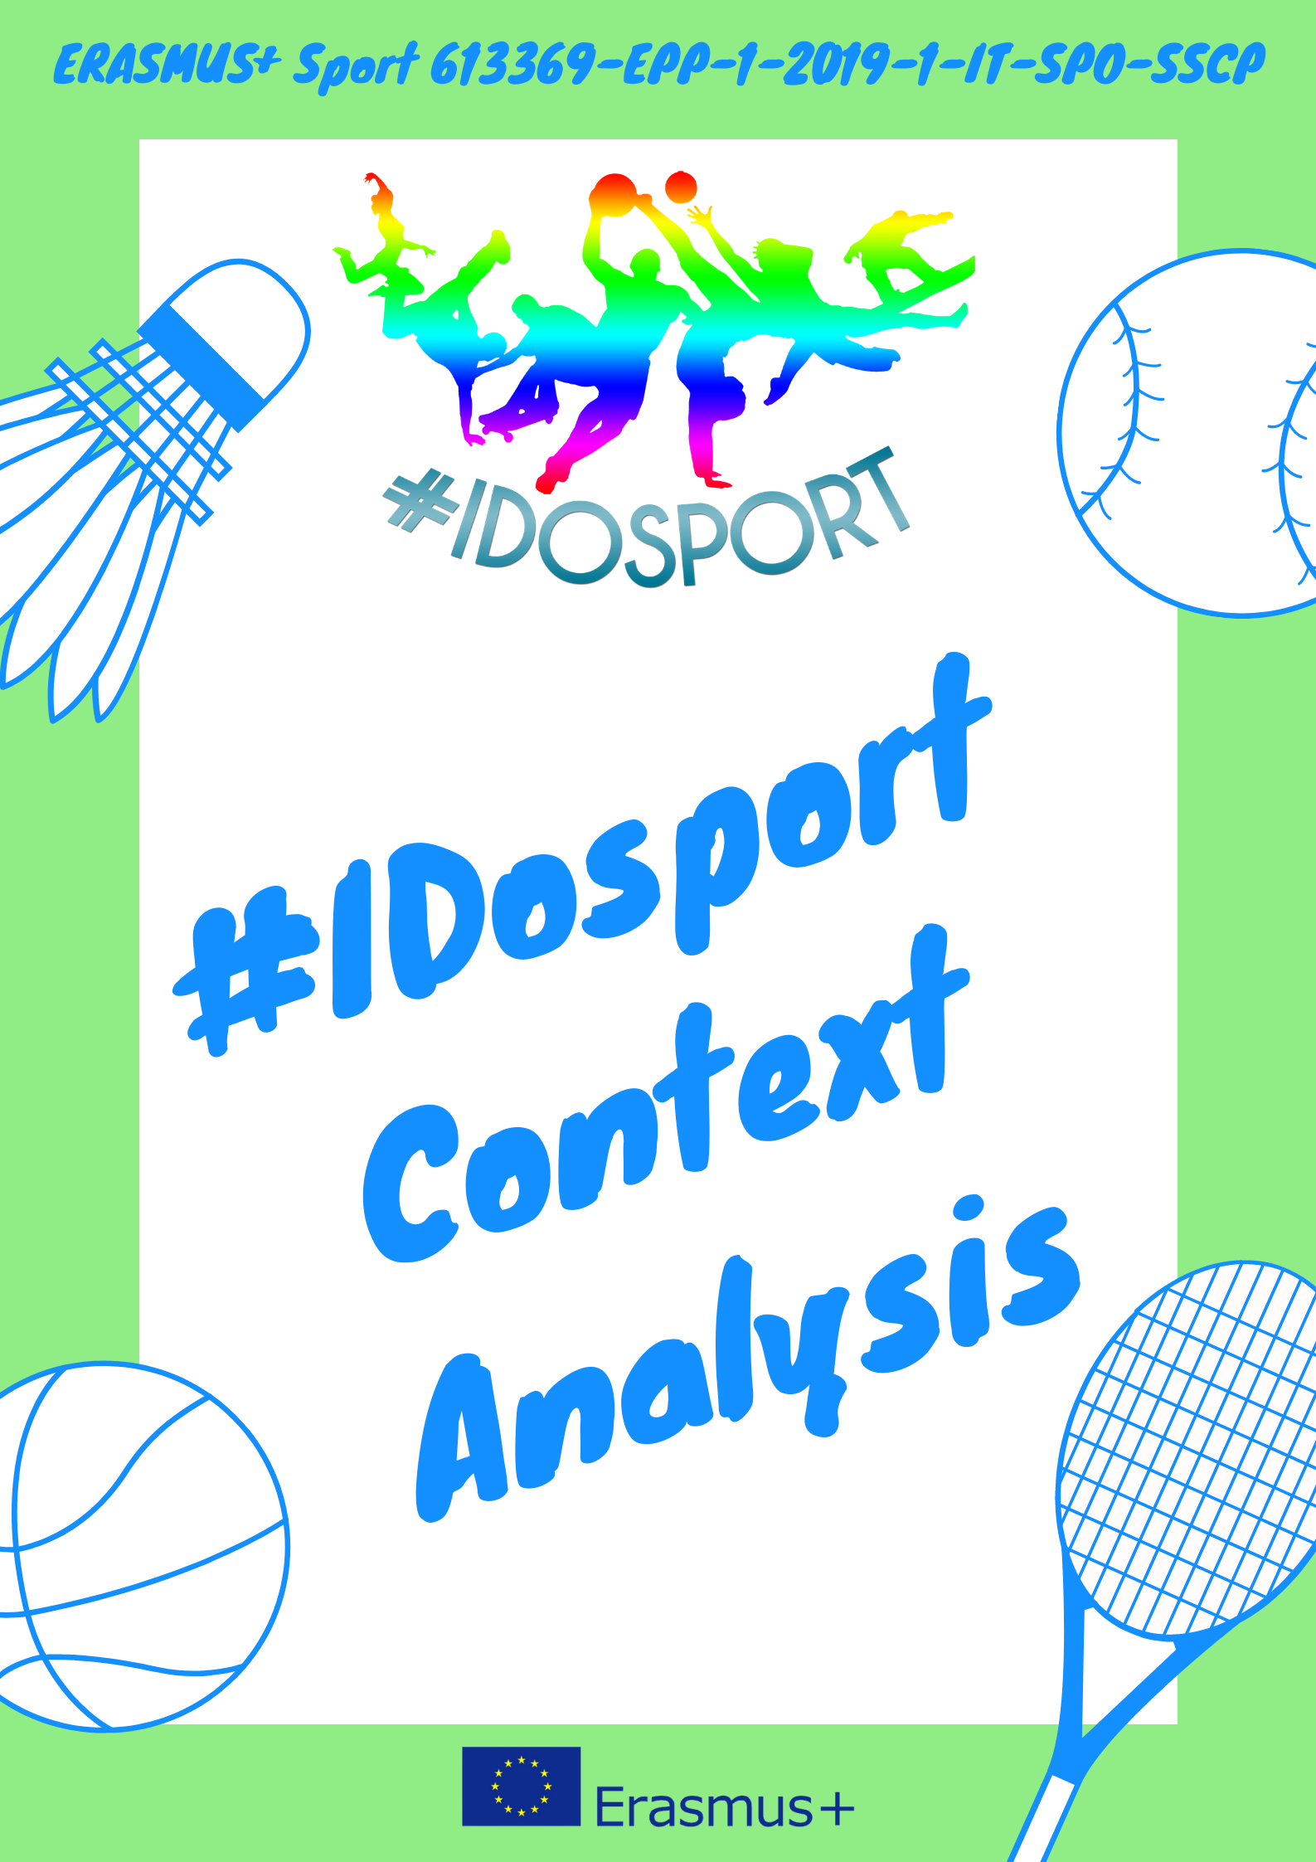
Project No. 613369-EPP-1-2019-1-1T-SPO-SSCP
#IDoSport: facing Intellectual Disabilities through sport
A European Union framework on the approach of sports for people with disabilities

Introduction
#IDoSport aims at promoting the sport practice as a vehicle of social inclusion and integration among people with relational and intellectual disabilities. As a second goal, the project gazes at promoting volunteering in sport, in order to enhance equal opportunities for everybody. Moreover, the project wants to make an endorsement to raise awareness on the importance of sport for health, especially for intellectual disabilities.
In order to be more effective and adress our target groups in the optimum way, with the right activities, all partners gathered information on the existing situation regarding the accessibility to sports for people with disabilities, in local and national level.
For the facilitation of the research, each partner tried to answer the same questions that cover the aspects that needed to be enlightened.
After having written down the context in five countries (Greece, Spain, Italy, Hungary and Lithuania), a common ground shall be created, drawing conclusions for an EU framework that will reflect the basic elements that we should focus on.

European Institute for Local Development (Greece)
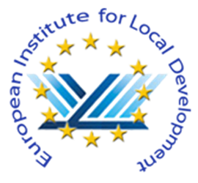
Does your province, region or government invest in sports? Are there funds and open calls for the development of sport aimed at people with disabilities?
In Greece, there is a serious lack of statistics on disability and accessibility, which makes it difficult to draw up data-informed analysis, both on national and local level.
However, a research was carried out, between December 2014 and March 2015, in Athens, Greece, for the needs of the WHO Disability Assessment Schedule (WHODAS 2.0), showing the chaotic difference regarding the difficulties of joining several social activities for people with disabilities compared to people without.
https://www.researchgate.net/profile/Evangelos_Alexopoulos/publication/294423180_Validation_of_the_World_Health_Organization_Disability_Assessment_Schedule_WHO-DAS_II_in_Greek_and_its_added_value_to_the_Short_Form_36_SF-36_in_a_sample_of_people_with_or_without_disabilities/links/56c89fe808aee3cee53d6e90/Validation-of-the-World-Health-Organization-Disability-Assessment-Schedule-WHO-DAS-II-in-Greek-and-its-added-value-to-the-Short-Form-36-SF-36-in-a-sample-of-people-with-or-without-disabilities.pdf
Sports for people with disabilities are a special state-sponsored sports field. Besides, the participation of people with disabilities in the social, economic and political life of the country is a constitutionally guaranteed right (Constitution of Greece, article 21, par. 6).
When it comes to funding, there are also no accessible data, although there are some numbers extracted from the National Statistics Agency that can help us with some assumptions. Below we can read about the funds allocated to people with disabilities. The main observations that have to be made are two. Firstly, the funds are decreasing year by year from 2015 to 2018. Secondly, social protection benefits are in their vast majority in cash form, while benefits in kind are far less. This last element is important to us, because benefits in kind refer to our research interest, as they may refer to development of sports aimed at people with disabilities.

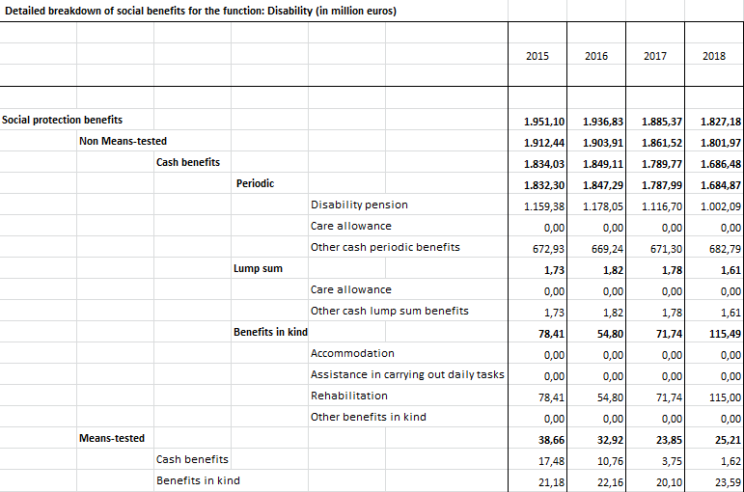
https://www.statistics.gr/el/home?p_p_id=com_liferay_portal_search_web_portlet_SearchPortlet_INSTANCE_3&p_p_lifecycle=0&p_p_state=maximized&p_p_mode=view&_com_liferay_portal_search_web_portlet_SearchPortlet_INSTANCE_3_mvcPath=%2Fview_content.jsp&_com_liferay_portal_search_web_portlet_SearchPortlet_INSTANCE_3_redirect=https%3A%2F%2Fwww.statistics.gr%3A443%2Fel%2Fhome%3Fp_p_id%3Dcom_liferay_portal_search_web_portlet_SearchPortlet_INSTANCE_3%26p_p_lifecycle%3D0%26p_p_state%3Dmaximized%26p_p_mode%3Dview%26_com_liferay_portal_search_web_portlet_SearchPortlet_INSTANCE_3_redirect%3Dhttps%253A%252F%252Fwww.statistics.gr%253A443%252Fel%252Fhome%253Fp_p_id%253Dcom_liferay_portal_search_web_portlet_SearchPortlet_INSTANCE_3%2526p_p_lifecycle%253D0%2526p_p_state%253Dnormal%2526p_p_mode%253Dview%26_com_liferay_portal_search_web_portlet_SearchPortlet_INSTANCE_3_mvcPath%3D%252Fsearch.jsp%26_com_liferay_portal_search_web_portlet_SearchPortlet_INSTANCE_3_keywords%3D%25CE%25B1%25CE%25BD%25CE%25B1%25CF%2580%25CE%25B7%25CF%2581%25CE%25AF%25CE%25B1%26_com_liferay_portal_search_web_portlet_SearchPortlet_INSTANCE_3_formDate%3D1614157755036%26_com_liferay_portal_search_web_portlet_SearchPortlet_INSTANCE_3_scope%3Dthis-site&_com_liferay_portal_search_web_portlet_SearchPortlet_INSTANCE_3_assetEntryId=17117924&_com_liferay_portal_search_web_portlet_SearchPortlet_INSTANCE_3_type=document
For the development of the aforementioned field, associations and federations are established and recognized by the greek government, in accordance with the provisions of current legislation.
Important recognized sports federations in Greece:
- Sports Federation for Kidney Disease and Transplant Patients (https://www.aonm.gr/)
- Hellenic Athletic Federation of the Deaf (http://hafdeaf.gr/)
- Hellenic Wheelchair Basketball Federation (https://www.oseka.gr/)
- Hellenic Sports Federation for Persons with Disabilities (http://www.eaom-amea.gr)
- Hellenic Paralympic Committee (HPC) (http://www.paralympic.gr/en/)
Furthermore, the greek Law 2725/1999 according to article 34 provides benefits for people with disabilities who are distinguished athletes. More precisely, these benefits include:
- Special professional licenses for state lotteries, organizations of football prognostics, etc.
- Financial rewards for: distinguished athletes and trainers and distinguished transplant or dialysis athletes and their coaches.
- Appointments in the public sector for athletes, who have achieved at least one outstanding competitive distinction in individual or team sports.
- Facilities of other kinds, such as special permission to participate in training and sports matches.
- Opportunities for athletes with disabilities in higher education.
- Honorary benefits, such as awarding of a gold medal by the President of Greece.

Care for the Mentally Disabled of Pieria (Merimna Paidiou Katerinis)
“Merimna Paidiou Katerinis” is a greek NGO that was founded in 1979 in Katerini by a handful of concerned citizens. Its aim is to advance the rights and well-being of disabled people, especially the ones with mental disabilities such as autism, cerebral palsy and multiple disabilities.
This has been accomplished so far in two ways: by running facilities, that provide services to people with disabilities, and actions in the community, that shape a better society, a society of inclusion, through education and awareness.
Day Care Centres
Merimna is responsible for the operation of two Day Care Centres. The first one is located on Mytika and Iras streets with a total capacity of 66 people. The second one is located on 19 May 3 street with a capacity of 25 people. Both centres are licensed by the Regional Unit of Pieria to provide services to people with mental or physical disabilities. Both centres are completely renovated with equipment of the latest technology.
The centres are under the scientific supervision of a renowned psychiatrist and child psychiatrist and are staffed by trained and experienced staff in the field of providing services to people with disabilities.
Patients have the opportunity to participate in various activities, such as group occupational therapy, entertainment, sports, music, and dance events. Furthermore, they can attend workshops for bookbinding, waxing, decoupage, soap making and planting.
The operation of the structures is ensured by the inclusion of the beneficiaries in NSRF programs or by special compensation from EOPYY.
Be The Change – Summer Camps Project
The organization coordinates one of the largest Camping Projects in Greece, participating in the Panhellenic Federation of Societies of Parents and Guardians of Disabled People’s Camp Programmes every year. In recent years, they stay in the camps of Metamorfossi, Halkidiki and Agia Paraskevi in ​​Stomio, Larissa, with missions of more than 70 people.
For 10 days, campers enjoy swimming in the sea, sports and creative activities organized both by the coordination teams of the camps and by the organization itself. They meet and socialize with people from other organizations, actively participate in the activities and find refuge from their daily lives.
Does your association or other associations dealing with disabilities adopt the integrated approach of sports activities? What kind of experience do you have in the field?
The European Institute for Local Development has great experience in sports and it consists of experienced staff with excellent competences related to this field.
Thus, since our establishment, in 2009, we have participated in many European sports projects, dealing with various target groups, such as cancer patients.
More particularly, we have participated in the Erasmus+ project ONCOLOGY GAMES (2017-2018).
The aim of the project is to approach the cancer patients by encouraging them to participate in sports. It is very important for the cancer patient to be part of a sport game as it makes them feel unique, because sports allow everyone, at every level, to participate and get involved in a team/group.
Partnering with sport groups helps cancer patients boost their confidence and encourage them being physically active.
The project activities can be useful for cancer patients to familiarize with the idea of promoting sports as a means to help to the positive and strong in fighting and dealing with cancer, to feel as a “sick person who DOES NOT get sick” because he/she leads life, albeit fighting with the inevitable functional and organic problems and pains.
The project partners succeeded two general purposes: the idea to develop the European Dimension in Sport by promoting the link between health and sport for all; secondly to highlight sports’ role in promoting greater social inclusion.
In addition, our organisation has participated in projects focusing on people with disabilities.
In 2017, we participated in the Erasmus+ project “Stop ASD! HAZARDS”. The project had as priority to promote the social and labor inclusion of people with ASD through an innovative training, expanding and developing the capacities of all those professionals who directly or indirectly participate in training in occupational health and occupational risk prevention of workers with autism, at the same time.
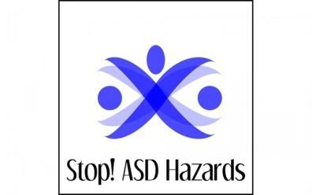
To achieve this, adapted training contents were designed to interact with the students and help them adapt to the required level, promoting self-learning. The training was complemented by the creation of a collaborative learning platform that integrated both local and regional leaders as well as people with ASD, and fostered transnational networks for knowledge exchange. A Manual of Good Practices for Occupational Health and Workplace Risk Prevention has also been developed to improve the professionals’ knowledge on how to prevent risks and take care of the ASD workers’ well-being.
All actions taken by EILD in the field of sports have been based on a previous need analysis and expectations of the respective groups of athletes, e.g. their age, their social background, whether they are professional or amateur athletes, whether they are disabled and their type of disability etc.
In addition, we have been member of projects targeting young people with learning disabilities, such as dyslexia.
Such project is the “iSmart Application”, that aims to digitally expand the memory of dyslexic pupils, to assist in eliminating the limitations that come with education as a dyslexic. The project provides dyslexic pupils and their parents a platform where notes from the classroom are easily accessible. This will provide a better learning experience to the pupils and more and clearer information to the parents.
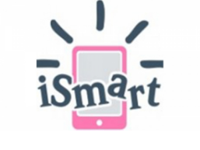
iSMART project develops a software that enables the transfer of text and other study materials from the classroom to pupils’ smart device. The concept is that the teacher will save all subjects discussed in class and will transfer them digitally to the smart devices enabling the pupils to access information remotely.
What is the perception of sports conducted by people with disabilities? Is it more/less known compared to the situation of 10-20 years ago?
Greece has been more active in addressing the issue of people with disabilities since joining the EEC and in particular in the 1980s. In fact, this decade has been described as a "golden age" for legislation related to persons with disabilities. Some of the most significant laws that were established that decade are:
- Law 1648/1986: “Warrior protection, for disabled and war victims and people with disabilities”
- Law 1836/1989: “Promotion of employment and vocational training and other provisions”

In Greece, sports for individuals with disabilities began to develop in the late 1970s and early 1980 with the first participations of Greek athletes in Paralympic Games and the establishment of the first sports associations.
During the 1990s, two Sports Federations for people with Disabilities were founded, the Hellenic Sports Federation for People with Special Needs and the Hellenic Sports Club for Physically Disabled People (PASKA).
PASKA was established in 1987 in Athens and is the first athletic association for people with disabilities in Greece. Its main goal and philosophy is the creation of permanent athletic structures and facilities specifically tailored for people with physical disabilities. PASKA contributed to the creation of the institution of the PanHellenic Championship for people with disabilities, starting in 1988.
Are there training courses for mixed ability sports? At what level (associations/committees/universities)?
Many people still face significant barriers to participating in mainstream sports through, for example, disability, age, gender, background or poor self-perception. Mixed ability sports take an innovative approach to break down these barriers. Participants from a wide range of background and abilities share experiences and learning through interactive and accessible training resources. This creates sporting environments that are safe, welcoming and non-judgmental. Mixed ability sports emphasize regular, frequent and sustainable activities, self-determination, club membership and opportunities for social interaction for everyone.
In Greece, the Athletic Association for the Development of Customized & Amateur Sports Culture was established in Veria in 2014 and is a member of the National Sports Federation for People with Disabilities.
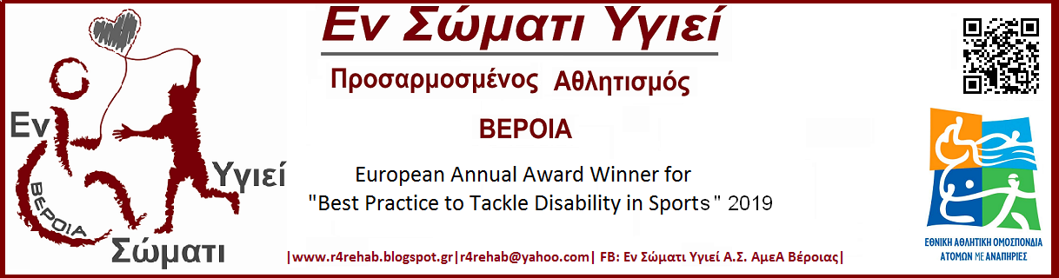
The purpose of the association is: «The moral upliftment of young people with any kind of disability (physical or mental) who have a will for Sports, Exercise, Racing Sports , the systematic cultivation of their potential, as provided by current legislation, but also people who love Amateur Sports, Physical Activity in general and Therapeutic Gymnastics - Physical Rehabilitation.
Also, the purpose of the association is the development of the spirit, the noble rivalry and solidarity between them, the exercise of the body, the maintenance and improvement of the good physical condition, the acquisition and the development of their physical abilities, their entertainment in general, the promotion of sociability and camaraderie, according to the basic principles of sportsmanship and "fighting well". In addition, the main purpose of the Association is the Development of Cultural Education that originates from Sports and its Promotion with specific and targeted actions».
Τhe Association has been awarded with the European Annual Award for Best Practice to Tackle Disability in Sports 2019.

Asindown (Spain)

Does your province, region or government invest in sports? Are there funds and open calls for the development of sport aimed at people with disabilities?
Speaking of the Valencian Community, in the first phase of diagnosis carried out in the project of the Strategic Plan for Physical Activity and Sport of the Generalitat Valenciana (PEEGV), directed by the biomechanics institute (IBV), the following results are obtained: in Regarding investments in sport and physical activity, these have evolved from € 24 million in 2015 to € 29 million in 2019, reaching € 5.85 per capita, far from the national average of € 7.5 per capita.
There are diﬀerent projects that, thanks to the collaboration between the Generalitat and the Federation of Adapted Sports of the Valencian Community, through the Ministry of Health, the Ministry of Education, Culture and Sports and the Ministry of Social Welfare, a contribution is made economic both for the development of sports activity in people with disabilities and for the acquisition of the necessary equipment for it.
There are also grants that can only be requested by non-profit sports entities that carry out actions and programs that promote the integration of diversity groups through physical activity and sport that develop their activity within the competence of the Generalitat Valenciana, excluding participation in official competitions.
With regard to adapted sports, in 2018, according to the Adapted Sports Federation (FESA), in the Valencian Community there are a total of 37 adapted sports clubs, of which 20 are in the province of Valencia, 10 in Alicante and 7 in Castellón.
Investment in sport at state level
The Spanish Federation of Sports for People with Physical Disabilities oﬀers the following information in relation to subsidies:
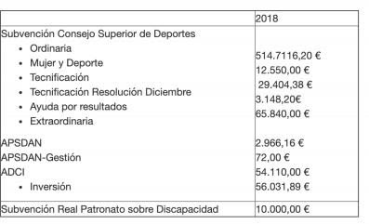
Article 30.5 of the Convention of the United Nations Organization (Spain, 2008) on the rights of persons with disabilities proposed:
- Encourage and promote the participation of people with disabilities in sports activities.
- Ensure their ability to organize and develop specific sports and recreational activities for the group.
- Ensure access to sports, recreational and tourist facilities.
- Ensure that children with disabilities have equal access to participation in recreational, recreational, leisure and sports activities as the rest.
The Comprehensive Plan for Physical Activity and Sports (CSD, 2009) accepted these proposals as necessary for the promotion of physical activity in people with disabilities at the national level. Likewise, in this plan reference is made to four main areas of participation of people with disabilities around physical activity: the federative associative, the autonomous and municipal, educational and health. These areas are necessary to contextualize the physical-sports practice in people with disabilities and to understand their different expressions. However, as indicated in the Comprehensive Plan for Physical Activity and Sport (CSD, 2009), the main difficulty in diagnosing the current situation of the participation of people with disabilities in the different areas of physical practice- sports is the lack of reliable and quantifiable indicators. The specific disability-related objectives of this plan are as follows: generalize the practice of physical activity and sport for citizens with disabilities, preferably in an inclusive environment and in a framework close to their social and family context, guarantee access and use and enjoyment in the design of sports facilities as a fundamental element in equal opportunities and improve the training and specialization of sports managers and public awareness.
Regarding the federative-associative sphere, the statutes of the Adapted Sports Federations of a state and regional nature have been revised and the common denominator in all of them is that the general promotion of sports modalities throughout the national territory must be ensured. This excludes, in a systematic way, the promotion of the practice of physical activity and sport, since they are based exclusively on the development of sports competition. Despite this statutory limitation, several entities tend to the promotion of physical activity and sport for people with disabilities, in general: the “Federació d'Esports Adaptats de la Comunitat Valenciana”, is an example of this. This federation carries out programs of interest for the promotion of physical activity and sport such as the "Knowing is valuing" program that aims to sensitize students and collaborate in the continuous training of teachers, the "Adapted Sports Work Camps" that promote the interaction between young volunteers with and without disabilities and the “Aquatic Activities and Sea Baptism” programs. There are also, in the associative fabric, some relevant experiences in the promotion of Sport and Adapted Physical Activity for people with disabilities, such as the Associació Joc Viu (Catalonia), the CAI Sports Adapted (Aragon), the Sport and Desafío Foundation (Madrid), the Also Foundation (Madrid), among others, all non-profit entities, aimed at organizing physical activities and sports for people with disabilities with different orientations, but all of them from a common denominator that is cover the leisure time of people with disabilities by practicing physical-sporting activity in traditional contexts (sports centers, schools and others) or in natural contexts (adventure sports, skiing, hiking, for example).
In addition to the Sports Federations, there are National Associations closely linked to sports practice, from an eminently recreational and utilitarian point of view, such as the Special Olympics entity, which offers a model to take into account in the promotion of sport and physical activity of people with intellectual disabilities and ASPACE, which focuses on people with Cerebral Palsy and which promotes the practice of physical and sports activity in its centers, in the same line of promotion and occupation of free time. Finally, it is also worth highlighting the initiative of the Spanish Paralympic Committee which, since 2008, has been developing a specific sports promotion program in three specific areas of action: promising young people, women with disabilities and the severely disabled.
At the regional and municipal level, pioneering programs have been analyzed in relation to promotion from public entities. For example, in our community, in collaboration with the Valencian Federation of Adapted Sports, “Sports on the beaches” has been promoted, with people with and without disabilities participating at the same time by adapting them to allow accessibility. The activity has been reinforced with the presence of technicians who direct the activities
In the educational field, the current Educational Law, LOE (Organic Law 2/2006 on Education), in relation to the inclusion of students with disabilities, is a good framework to advance in the improvement of the educational system. The formulation of the principles that inspire it and the vision of the social function of the educational system are useful in this direction. They are committed to a comprehensive system, understanding diversity as a basic premise of education and linking the inclusive nature of the system with equity and social cohesion. For all these principles to have a practical translation in schools, it will be necessary that both the regulations to be developed by law, as well as the resources that are dedicated, are in line with the principles formulated. In our educational system we must consider the two realities of schooling: the ordinary center and the Special Education center. In both cases, there is a lack of quantitative data that helps us to give a global vision of the situation of the real practice of students with disabilities, both in the Physical Education sessions, and in sports practice carried out outside of school hours. It is noteworthy, however, that the Higher Sports Council convenes at the Spanish School-age Championships sports modalities for students with disabilities in the specialties of swimming (intellectual, physical and cerebral palsy) and wheelchair basketball (physical disability), interspersing these competitions in the program of the school national championships. According to some studies consulted, active and effective inclusion is far from being widespread in schools. The main reasons are the lack of teacher training, the number of students per classroom, the lack of human resources to support and advise teachers. For all this, it is common to observe how the practice of physical education of students with disabilities is replaced by physiotherapy, by theoretical work or by the performance of individual work, apart from the class group. Regarding the Special Education centers, it is worrying to note that in the subsidized centers the hiring of the Specialist Teacher in Physical Education is not considered mandatory. Even in some Autonomous Communities this is an unrecognized place in public centers. All this, together with the difficulties related to the transport of students with disabilities to sports facilities, the lack of adequate sports spaces in these same centers and the evident lack of human resources to accompany students, hinders their participation in Sports and Activities Adapted Physics. Likewise, in the specific case of the practice of Sport and Adapted Physical Activity in Spanish universities, there is not enough data to help us affirm that this practice is sufficiently attended,
In the health field, there are few experiences in promoting physical activity and sport in this field. The main reasons are the non-inclusion in the health center staff of technical figures in physical activity, the insufficient recognition of Physical Education programs in the health field as a valid resource for a functional rehabilitation of people with disabilities and the scarce infrastructure of sports facilities in health care centers. However, as noted in the section referring to the federative-associative field, there are some specific experiences that are significant for their contribution in this field.
Finally, it is considered of interest to offer the results of a study on sports habits of people with disabilities in the city of Barcelona - and which could well be extended to most Spanish cities - carried out in 2003 by the City Council of Barcelona. According to the total data provided, the following are concluded:
- Of the different types of disabilities, people with physical disabilities practice the most, followed by people with intellectual disabilities and people with sensory disabilities. Furthermore, there are people with mental disorders.
- Regarding gender, women practice to a lesser extent but without notable differences.
- The most important reason for practicing sports is the promotion of health under a notable influence of medical prescription depending on the type of disability, especially in the case of women. Men show motivations linked to the concepts of fun, spending time with friends and self-satisfaction.
- One of the alleged reasons for not practicing physical or sports activity is the lack of adapted sports facilities and, paradoxically, health problems. In the second term, age, transportation difficulties and lack of time appear.
- The reasons for abandoning the practice are summarized in two: lack of time and financial aspects.
- The same people with disabilities tend to limit themselves to the practice of physical activity and sport, building psychological barriers and false beliefs that influence the maintenance of passive attitudes.
- The population with disabilities who practice sports in a federated manner does not reach 3% of the total.

All sports facilities in the province of Valencia have good accessibility for disabled athletes and therefore these are the ones used for sports, that is, there are no facilities only for disabled people. Moreover, in Spain there is an "Accessibility Law" by which there is an obligation to provide comfortable and easy-to-access facilities for people with any type of disability.
But our reality is diﬀerent. All the courses have problems to have the indoor facilities, since there is a saturation of demands in all the facilities in the city of Valencia, which is our area. In our morning programs, we do have indoor facilities, since the volume of requests from sports clubs is lower in the mornings. but it is in the afternoon when we have the problem, they only allow us to rent facilities abroad, we cannot get any course to allow us to have indoor facilities.
This negatively aﬀects the attendance of our athletes during the cold months of November, December, January and February. Families are reluctant to attend when the temperatures are low to avoid colds and respiratory infections. This hurts us a lot in the dynamics of the groups, since it cuts the rhythm of the group, although we try that the individual progression does not aﬀect these setbacks too much.
Diﬀerence between public and private clubs, are there data or statistics ?. Who runs them? What are the sources of funding? Municipality, Province, Region, State? Are there links? Insert them.
In Spain, public sports facilities belong and are usually managed by municipal and regional institutions and by national institutions. These three types of organizations present some diﬀerences both in relation to their objectives, the resources available to them, as well as in their organization and structure, but all of them can constitute the opposite group to private facilities, which can be divided into commercial organizations, organizations non-profit social interest and recreational clubs owned by a number of members thereof.
Regarding public facilities, we can say that they are financed and directed mainly by the City Council, while the private ones are directed and financed by themselves.
No statistical data has been found on clubs in the Valencian Community.

What are the investments in sport in the analyzed area? Are there any associations / organizations of people with disabilities that you have applied for? If so, what number? How much funding is allocated to projects with disabled beneﬁciaries?
There are numerous associations that request aid and financing from the State and also from private companies.
In the Valencian Community there are subsidies for non-profit sports entities that promote the integration of diversity groups through physical activity and sport:
The budget allocated to finance this call will amount to a maximum of 500,000 euros, charged to the Generalitat's budgets for 2021.
- Up to a maximum percentage of 70% of the budget of the program presented may be subsidized.
- The maximum subsidy to receive will be 10,000 euros per project.

Associations like ours, and others that work with this group of people, request many of the grants. Private companies such as Mercadona (among others) through its Trinidad Alfonso Foundation, also help some financially.

For example, the Spanish Federation of Sports for People with Intellectual Disabilities (FEDDI) have public subsidies:
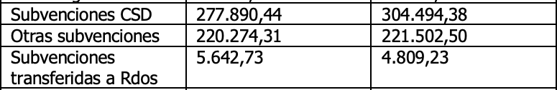

What is the state of the sport at the state level? Breakdown the data into sports funds and sports funds for people with disabilities. -Link of sports calls.
In Spain, sports federations will receive a total of 66.8 million euros in 2021, 12.7 million euros more than this year, representing an increase of 23.5%. Aid to athletes increases by 53% by results obtained, by 42% the item for operating expenses and activities of the High Performance and Technification Centers.
The accounts presented double the current budget allocated to Women's and Inclusive Sports. The total allocation reaches 2.5 million for projects of the federations related to Women and Sports and Inclusive Sports. It is an increase of 112%.
At the provincial level, no information has been found on funds allocated to sports for people with disabilities.

Do your associations or other associations dealing with disability adopt the integrated approach to sports activities? What kind of concrete experience do you have? Which sports do you promote, specify the connection to the disability. Do you promote integrated sporting events / competitions? If so, which ones? Examples, links. Describe the integrated approach taken: what activities do you usually do? What? How integrated can your activities be? Do you have models?

At the Asindown Foundation, we opt for an integrated and comprehensive approach to our sports programs. As we have already mentioned, we oﬀer sports programs that seek to eliminate the barriers related to the practice of physical activity that people with any type of disability continue to have today, since through our sports activities we seek and promote integral development of our users: cognitive development, development of physical condition, development of social skills, increased quality of life, acquisition of healthy lifestyle habits, education in values... and a large number of aspects that physical activity allows us to enhance

Despite the fact that there are diﬀerent articles that demonstrate the benefits that physical
activity has on these aspects, in these 2 and a half years of travel, despite the fact that we are aware that the objectives we seek are achieved in the long term, we have been able to experience the progress of our users at all levels, notably improving their quality of life, which is directly related to an increase in the practice of weekly physical activity that we oﬀer to our users.
As for our specific experiences, as we have mentioned, we have been conducting Physical Activity sessions for people with Intellectual Disabilities for more than two years, using the integrated approach, so our experience in this section is extensive.

What sports do you promote, specify the connection to disability?
From our entity we promote the practice of:
- Physical Activity for older adults: to our users of the Inclusion Support Center with the main objective that they increase their practice of physical activity (since the levels of PA practice of the population with disabilities is well below the levels of PA in the general population, especially in adults) to obtain improvements in health and quality of life.
- General Physical Activity (more didactic character): to our users of the Training Area and the CAI, with the main objective of creating active and healthy life habits through diﬀerent adapted games and sports, always from a perspective of education in values.
- Physical Activity in nature with a recreational nature, in leisure time as a socialization tool (hiking), with the main objective of continuing to break down barriers, in this case some of the barriers that people with disabilities have to occupy their leisure time and that allows them to socialize with other people with and without disabilities.
- Physical-sports activities through diﬀerent sports modalities such as Basketball and Athletics.
- Do you promote integrated sporting events / competitions? If so, which ones? Examples, links.
Currently, Asindown does not directly promote competitions, although there are several ongoing projects that contemplate future participation in certain federated competitions. From time to time, diﬀerent sporting events are promoted in order to encourage the practice of PA and give visibility to this sector of the population through PA (for example, last summer a solidarity virtual race was created).
Describe the integrated approach taken: what activities do you usually do? What? How integrated can your activities be? Do you have models?
In the diﬀerent sessions that we carry out in our sports programs, we carry out integrated activities focused on improving basic physical qualities that will lead to an improvement in our health. In this way we focus on performing tasks and games related to ﬂexibility, Strength (very important, especially in adults for maintenance) and Endurance (great importance of aerobic endurance), since the WHO does not consider Speed as an important physical quality for health, giving great importance to the playful component to increase the motivation of our users. These activities are carried out with the methodology explained above and we always keep in mind its integrating nature.

What is the perception of sport practiced by people with disabilities? Is it more / less known than the situation 10-20 years ago? History-context of disability and sport in the last 20 years. What kinds of changes have there been? What situation do we start from? Stereotypes that you managed to break? Conquests? What was the starting point? (usually)

History of disability and sport in Spain:

Adapted sport in Spain began to be promoted in the 1960s. In the specific case of Spain, the first steps took place in 1958 in Barcelona, where the Hogares Mundet welfare complex was inaugurated to welcome homeless children and young people , among which there were a large number of those aﬀected by polio sequelae. The novelty of this center is that it begins to promote sports activity among young people with disabilities. Also in the early 1960s, Dr. Ramón Sales, at the Hospital Valle de Hebrón, applied the idea of rehabilitating young paraplegics through the practice of wheelchair basketball (Luis Leardy and David Sanz, 2018). Specifically, in 1963, the first national competition was held, known as the “I Olympiad of Hope” in which Paralympic athletes from 11 cities in the country participated. Three years later, Madrid hosts "The Overcoming Trophy" known for being the first national sports championships for people with disabilities. As a result of the 20 diﬀerent activities that began to develop around this sport, the first institution of Paralympic sport in Spain emerged in 1968: the Spanish Federation of Sports for the Handicapped (FEDM). However, over the years, the agency realized that a specialization was necessary according to the type of disability (Luis Leardy and David Sanz, 2018). This new reality and the demands of each group coincided in time with the enactment of Law 10/1990, of October 15, on Sports and with the development of the Royal Decree of Sports Federations of December 20, 1991, and both texts legal drew up a new structure for Paralympic sport in Spain. As a result of this, the Spanish Federation of Sports for the Blind (FEDC) and the Spanish Federation of Sports for People with Cerebral Palsy (FEDPC) were created in 1993. And the FEDM becomes FEDMF (Spanish Federation of Sports for the Physically Handicapped, currently renamed the Spanish Federation of Sports for People with Physical Disabilities (FEDDF)). But, in addition, in accordance with the new Sports Law, the Spanish Federation of Sports for People with Intellectual Disabilities (FEDDI) and the Sports Federation for the Deaf (FEDS) were established. Once the five sports federations for people with disabilities were created at the beginning of the 90s, they soon realized that, once their specificities had been safeguarded, the only way to defend their interests as a group was from the unity of action, which led to the creation of the Spanish Paralympic Committee (CPE). Barcelona 1992 marked a before and after in the history of the Paralympic movement, since the Spanish city gave consistency to the Paralympic Games as we know them today. In addition, other great innovations were also produced, such as the first-time performance of doping controls on athletes and, above all, the introduction of a new method for classifying disability that allowed athletes to be grouped according to their physical and sporting ability. 2001 is another date to stand out in Paralympic sport. In this year, the International Olympic Committee and the International Paralympic Committee signed an agreement to protect the Paralympic Games and ensure the practice of “a single candidacy, a single city”.
Last decades:
The latest official data that we have dates from 2008. In Spain, according to the Survey on Disability, Personal Autonomy and Dependency Situations of 2008 (EDAD 2008), carried out by the National Institute of Statistics (INE), there are almost 4 million of people who live in a situation of disability, to whom, if we add the almost 300,000 in centers, they become 9% of the population. According to data from EDAD 2008, 28.3% of the disabled population dedicated their free time to doing some type of physical exercise, ranking as the first option in the repertoire of activities to which they would like to dedicate their free time (23% ). In this case, there are data that reﬂect inequality between men and women. While 36.09% of men with disabilities dedicated their free time to physical exercise, only 23.17% of women did so. But, on the contrary, a higher percentage of women 15 wanted to spend their free time doing physical exercise (24.06% versus 21.34%). In this way, we can consider that there are gender inequalities in the inclusion of the population with disabilities.
Present:
Currently there are no official data on sports practice of people with disabilities in Spain. The "Survey of sports habits in Spain" carried out by the Higher Sports Council does not include any data on this subject. But the Spanish Federation of Sports for People with Intellectual Disabilities (FEDDI) is the one with the highest number of licenses, with 5,368 in total, followed by the Spanish Federation of Sports for the Blind (FEDC), which has 1,772 members; 1,543 licenses in the Spanish Federation of Sports for People with Physical Disabilities (FEDDF); 1,352 in the Spanish Sports Federation for People with Cerebral Palsy and Acquired Brain Damage (FEDPC), and the Spanish Federation of Sports for the Deaf (FEDS) is made up of 907 people (Consejo Superior de Deportes, 2018). In relation to the distribution by gender, according to the data extracted from the "Yearbook of sports statistics" of the Superior Council of Sports of 2018, the federated licenses according to sex by federation, women only represented 27% of all athletes with intellectual disabilities ( 1,450 of 5,368). Regarding physical disability, women were 14% of athletes (217 out of 1,543).
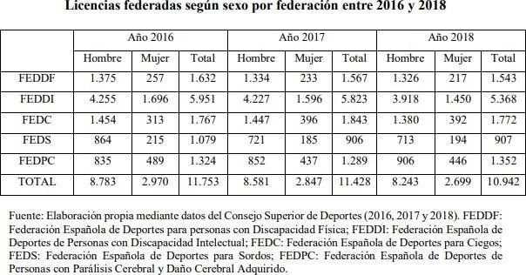
The absence of real data on sports habits of women with disabilities is an obvious obstacle when it comes to knowing in depth the situation of the subject in Spain. We can look at two aspects such as the number of Spanish federative licenses on the one hand and the data on women's participation in the Paralympic Games on the other. In the first place, we have already commented previously that female representation did not exceed 25% in 2018 and federated licenses, in general, have been decreasing over the years. Regarding the participation data in the Paralympic Games, the representation of women has experienced an upward progression since the 1980s (CPE, 2019).
Currently in Spain we are working through a structuring model, in which institutions and entities work to make the practice of this sport possible. In this model there are: the Higher Sports Council, the Spanish Paralympic Committee, the Adapted Sports Federations, the Territorial Federations and the Clubs. There is a support plan for athletes with disabilities, Support for Paralympic Objective Sport (ADOP). This project is an initiative that seeks to provide Spanish Paralympic athletes with better conditions so that they can carry out a better preparation when participating with the Spanish Team in the Paralympic Games. Within the Spanish State, each Autonomous Community has diﬀerent competences in relation to sports.
For all the above, we can see that society's perception of physical activity and sport for people with disabilities has evolved considerably in recent decades. Currently the visibility of this sector of the population in sports practice has increased and we have more information, knowledge and resources to oﬀer quality PA adapted to the characteristics of people with disabilities. The changes have been innumerable, among which we can highlight the elimination of some of the existing barriers in this area, a greater awareness of society and the increase in entities and organizations that fight for the rights of this sector of the population. Despite this, there is still a long way to go and many stereotypes to break.

Are there training courses for integrated mixed skills sport? At what level (association / committees / university)? What is the current situation in terms of coaching and training? Are there university courses / masters dedicated to integrated sport? Does your association promote any? If yes, link and description. Any team of mixed ability?
There are various training courses on physical activity and intellectual disability, oﬀered both at the university level and through business schools or various institutes. At the university level, in our country training in this matter is scarce, since there is hardly a subject dedicated to it during the 4-year career where the diﬀerent aspects of it are not dealt with too deeply, and there are hardly any university studies that address disability and physical activity specifically.
Currently, our entity is preparing a course / workshop on physical activity and intellectual disability that will be oﬀered from May of this year. It is a workshop of approximately 10 teaching hours in which concepts related to PA and Intellectual Disability will be explained, emphasizing the methodology used by the entity.

SporT21 Italia (Italy)

- Does your Province, Region or the Government invest in sport? In particular are there funds and open call for the development of sport aimed at people with disabilities (intellectual and physical)?

After Sochi 2014, the president of Italian Paralympic Committee affirms that Italy is "a country that does not believe in sport and does not recognize any rehabilitative role". A strong accusation beyond the sporting failure at the 2014 Paralympics in Sochi, with Italy returning home without any medal, the problem is much broader and regarding the lack of "serious investment" in sport and its rehabilitative and inclusive strength for people with disabilities.
Four years later the same President affirmed: “Today there is a greater awareness of the rights of disabled people. If we have arrived at the image of a disabled person declined positively and not necessarily as an object of assistance, it is also thanks to sport", he added. It was a cultural revolution.

But, let’s step back to how is sport for disabled people organized in Italy.
As regards sport for disabled people, in our country the reference body is the Italian Paralympic Committee (CIP), born in 2003 with a state law and recognized as the Confederation of Paralympic Sports Federations and Disciplines, with the task, both centrally and locally, to promote and guarantee the maximum diffusion of the sporting practice of disabled people in close collaboration with CONI (Italian National Olympic Committee).
The Italian Paralympic Committee (CIP) coordinates sports activities on the national territory through the Federations and Paralympic Sports Disciplines:
Some are affiliated with both CONI and CIP because they have a Paralympic section within them, such as FITARCO (Italian Archery Federation), FIC (Italian Rowing Federation) and FCI (Italian Cycling Federation)
Others are affiliated only to the CIP because they deal exclusively with Paralympic sports. These include the federations that coordinate all sports practiced by athletes with specific disabilities, such as FISPIC (Italian Federation of Visually Impaired and Blind Sports), FSSI (Italian Deaf Sports Federation) and FISDIR (Italian Federation of Intellectual and Relational Disabilities).
Like CONI, on the national territory the CIP is structured and organized in Regional Committees. At a territorial level it promotes amateur sports (amateur), while at a high level it deals with the preparation of national teams for the summer and winter Paralympic Games, which take place about two weeks after the Olympic Games in the same locations and structures as the Olympics.
The CIP collaborates assiduously with the world of the school, there are many calls that invite the institutes to carry out projects to bring disabled children closer to sport. Furthermore, thanks to agreements with the Ministry of Education and Research, some Paralympic disciplines are included in the Student Sports Games. On the CIP website you can find all the projects dedicated to schools born from agreements between CIP and MIUR.
For intellectual disabilities, Special Olympics is an important reality: it is an international sports training and athletic competition program, present in over 170 countries around the world and recognized by the CIP as a Meritorious Association.
In Special Olympics sporting events all participating athletes are rewarded, on the basis of tested and updated international regulations, sport is intended above all as a tool to increase the autonomy and social integration of the person with disabilities, which is why it is less focused on competitive spirit. On the Special Olympics website you can find out about the existing sports disciplines, sports federations and sports promotion bodies affiliated with the organization.
In 2020, Sport e Salute SPA, a in house society of the Ministry of Economy and Finance, considering the annual report of Istat “Discovering Disability” committed to promote 8 project facing disabilities.
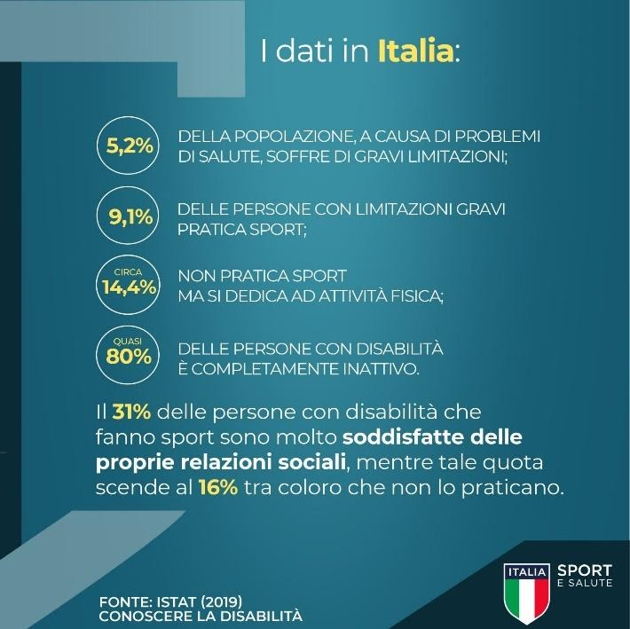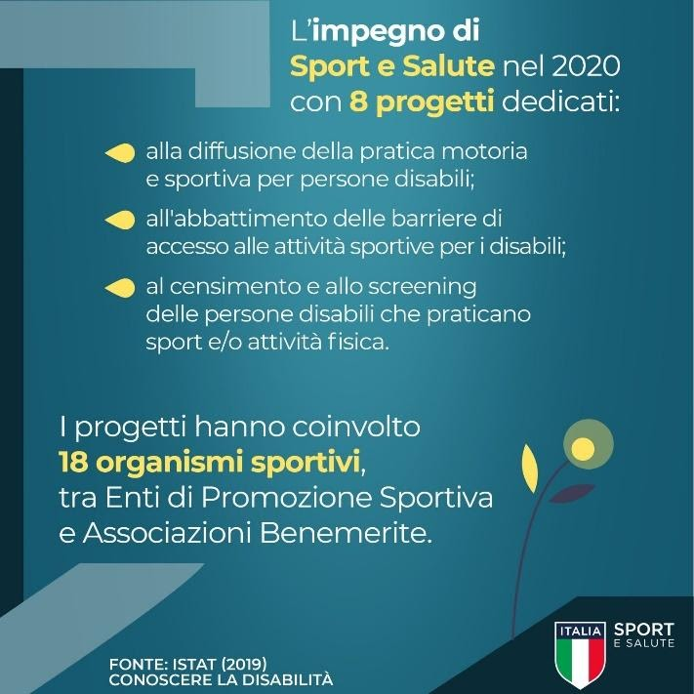
Sport e Salute (the company that replaced Coni Servizi) has distributed 280 million public resources to the world of sport for 2020. About 25 million will go to the "social" sector. The allocation of public grants to sports organizations for next year was approved by the Board of Directors. “For the first time - a note reads - the social function of sport finds space”. In essence, more money was assigned to grassroots sport, privileges for low-income groups, young people and over 64s, but safeguarding the federations already at work in view of Tokyo 2020.

Friuli Venezia Giulia is the Italian region that invests more in Sport and Disabilities and also the reason why associationism related to integrated sport is advanced. The area is governed by the regional law 3/2003 that includes articles facing disabilities. We’ll look into its funds system.

SPORTS FUNDS
- Sports events: Contributions for sports events that take place from 1 January of the year following the submission of applications until 30 April of the following year.
- Purchase of sports equipment: Incentives for non-profit sports associations and clubs for the purchase of sports equipment.
- Support for the institutional activities of sports association: Annual contributions to regional committees of Friuli Venezia Giulia of national sports association with an organized presence in the region.
- Sports activity of Paralympic associations for people with disabilities: Support for the sporting practice of people with disabilities.
- Contributions for sporting events and the purchase of equipment, equipment and means of transport for people with disabilities: Interventions in support of sports practice and the integration of people with disabilities.
- Interventions for the CONI Regional School of Sport: Funding for the training and updating of managers and operators of sports associations and clubs, regional committees and delegations of federations and other sports institutions operating in the regional territory.
- Enhancement of sporting talent: Funding for scholarships for athletes and sports technicians and for carrying out study programs and medical surveillance, relating to the enhancement of sports talent.
There are several sources of financing: in FVG there are around 2500 sports associations, of those 50 are directly involved in sports with disabled people. All these associations can access the regional funds, in particular there are calls reserved to special sports.

2. Do your associations or other associations dealing with disabilities adopt the integrated approach of sports activities? What kind of experience do you have in the field?
From 2016 Sport21Italia has been promoting Adria Inclusive Games: a non-competitive sporting event reserved for athletes with intellectual / relational disabilities. Sport21 cooperated with IMAS, international mixed ability sports and follow the method offered by IMAS.
At national level there is still limited access to integrated sports, because results are still the goal competitive sports events. Ideally integrated sport is enforceable in every activity, even the individual ones.
Many people, in fact, still face significant barriers to participating in mainstream sports through, for example, disability, age, gender, background or poor self-perception. Mixed Ability takes an innovative approach to break down these barriers. Participants from a wide range of background and abilities share experiences and learning through interactive and accessible training resources. This creates sporting environments that are safe, welcoming and non-judgmental. Mixed Ability emphasises regular, frequent and sustainable activities, self-determination, club membership and opportunities for social interaction for everyone.
3. What is the perception of sport conducted by people with disabilities? Is it more / less known compared to the situation of 10-20 years ago?

“Sport has the power to change the world,” Mandela said. “It has the power to inspire. It has the power to unite people in a way that little else does. It speaks to youth in a language they understand. Sport can create hope where once there was only despair. It is more powerful than the government in breaking down racial barriers.
Nelson Mandela

Sports practice has significant positive effects on well-being, including mental health. In fact, physical activity contributes to the functioning of the cardiovascular systems and respiratory, in addition to strengthening the osteoarticular and muscular systems, as well as keeping weight under control and preventing numerous chronic diseases. Physical activity practiced regularly has positive effects also in the psychic and relational field, because it has a positive impact on mood and individual self-esteem levels. The environment in which sport and physical activity are practiced can also become a positive context in which to build rewarding social relationships.
When we talk about the practice of physical-sporting activity we should always refer to one activity intended for the entire population ("sport for all"), without any dependent limit from health conditions or individual difficulties. This definition is also defined in article 30 of the UN Convention on the Rights of Persons with Disabilities and marks a total rupture with the meaning of sport identified as a competitive activity for a few champions, connected to a concept of a body without physical defects and limitations, solely linked to winning performances and the conquest of one record after another.
Persons aged 14 and over by practice of sport and physical activity, gender, age group and severity of limitations. Average 2016-2017 (percentage values) ex Istat
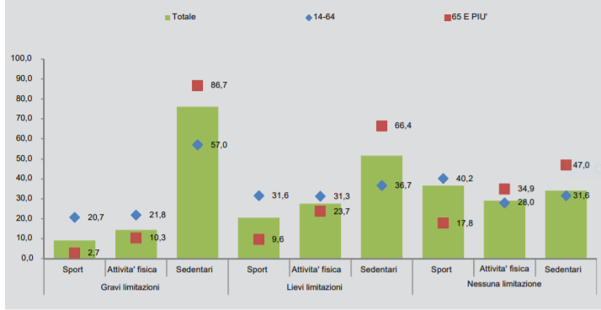
In the past, for people with disabilities there was no possibility of practicing sports activities, especially at a competitive level. It was only in the twentieth century that the first international sporting events appeared, promoted within one of the individual categories of disabled people. In Italy, on 17 November 1924 was founded the first “Deaf-mute Football Club.
People with severe limitations who practice sports, continuously or occasionally are still only 9.1%. The percentage of sportspeople increases significantly when limitations are less severe (reaching 20.5%). Closer to the data of the population without any limitation that corresponds to 36.6%. People with severe limitations who, while not practicing sports, perform some physical activity, are 14.4% (less than half of the value achieved from the population that has no limitations, 29.1%). Among people with fewer limitations serious, those who engage in physical activities are 27.6%. Out of 10 people with severe limitations, about 8 report being totally inactive, sedentary, against 34.1% registered among the population without limitations. In line with a general trend in Italy, significant gender differences also occur among people with severe limitations (13.7% of men play sports, but only 6.0% of women) and age (sports 20.7 of people under the age of 65 against 2.7 of the elderly). There is, in addition, territorial distances with a marked North-South gradient: 11.9% of people with severe limitations residing in the North, against 6.3% of those living in the South.
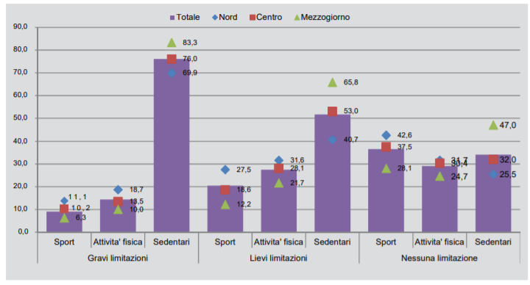
Persone di 14 anni e più, per pratica di sport e attività fisica, per ripartizione geografica e gravità delle limitazioni. Media 2016-2017 (valori percentuali) Istat
Awareness towards sport and disabled people has deeply changed: thanks to various no-profit organizations sport has become a right for all. Nowadays we can affirm that there is a new perception of rights related to people with disabilities: the disable is seen as the protagonist of himself in an increasingly inclusive society, comprehending personal and social well-being activities.
A greater awareness of disabled’s rights has been reached and cooperation between sports associations and local entities dealing disabilities has been positively launched and implemented. Realities born with different goals has been converging towards the defense of people's rights.
Various movements focusing inclusion and integration of people with disabilities have been cooperating (Paralympic, mixed ability association, Special Olympics). Associations dealing with disabilities have grown and set their goal into independent life for each person with disability. Today we assist to an opening on various sports disciplines thanks to an attitude that is less and less paternalistic and that promote their self-realization and desires.
Moreover, it’s relevant to point out that it is estimated that almost one million people declare that they do not play sports and have never practiced it in life and that they indicate as motivation of this lack of practice is precisely the presence of disabilities. Furthermore, most of these people (about 8 out of 10) do not even practice any type of physical activity (Istat, 2015)
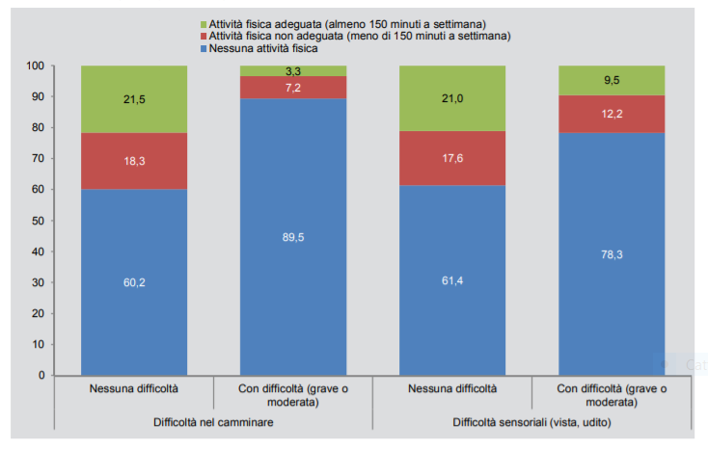
Sport is a significant tool for integration and inclusion of all people at risk of marginalization, including people with disabilities, allowing them to know their body in all its potential, placing it in a positive perspective to be valued and expressed and not seen as an obstacle and impediment; in this sense sport revolutionizes their point of view, providing hope and new goals. Sport assigns everyone a role, a specific task in a collective context, thus succeeding in breaking down the walls that are created outside, because in sport everyone is the same.
Are there training courses for mixed ability sport? At what level (Association / committees / universities)?
In the previous two years Sport21 coaches has been training in mixed abilities.
https://drive.google.com/file/d/1yyyj8g0E9cmn3eJdvKuLFlJRhjIZ26zh/view?usp=sharing

For instance, in 2019 “Carovana dello sport Integrato” project was implemented in Italy: "We have brought the message of integration possible through sport around Italy. We have become bearers of the values ​​of the country and we have managed in everyday life to take a long path of inclusion that today does not end, but opens a new phase for the rights of all ”. These are the words of Andrea Bruni, head of Csen (National Sports Education Center) for the project of the Integrated Sports Caravan, an 8000 km long journey that lasted two months. “The Charter of Values, which we brought with us, was signed by over 1500 people. It talks about sustainability, respect, happiness for everyone. It speaks about a sport in which everyone is needed ".

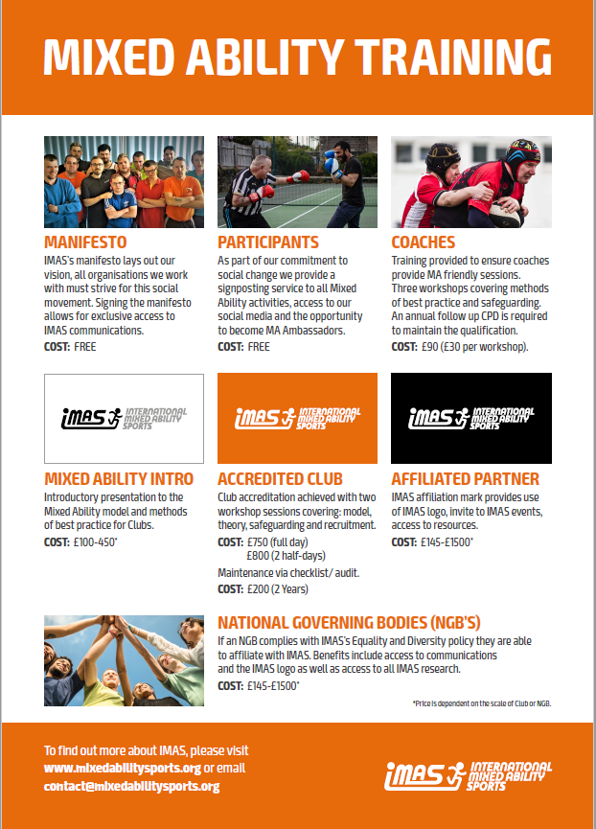

Hungarian Down Foundation (Hungary)
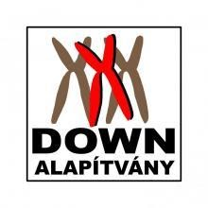
Does your Province, Region or the Government invest in sport? In particular are there funds and open call for the development of sport aimed at people with disabilities (intellectual and physical)

It is important to mention there is a serious lack of data about the sport habits of PWD. Statistics do not often cover/represent people with disabilities. The following table shows the total population and the number of people with any kind of disabilities.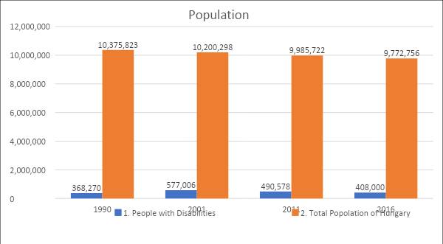

Budapest is the capital of Hungary with 1,7 million inhabitants. offers to the PWD (People with Disabilities) at most discounted entry to the sport complexes or without discount Our government supports mainly the competitive sport than the freetime sport possibilites. Mostly the cultural programmes which are free for the PWD, such as visiting museums, music concerts, galleries. There is a programme/application for PWD ’s which supports their holiday or vacation if their total aid does not exceed a certain amount, then in that case a significant part of the costs is covered by the state.
The table below shows the population of the capital including PWD and those who engage in regular sport activities. The charts do not only represent data from the capital it is across the country and it is not only about intellectually disabled people. It shows athletes who do sport regularly in sports clubs.
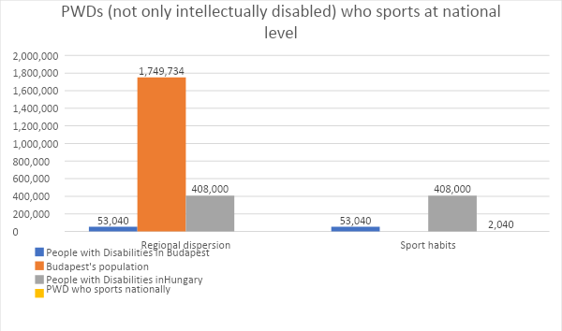
After these charts evaluation we can see only the 0,5% of the PWD are physically active (frequently). The statistic makers mainly got three types of answers from the PWD for that question why don’t they sport.
These answers were:
- It is not well accessibility.
- The price of the services are too expensive, they can’t afford it.
- They don’t have enough information about the sport and freetime activities. They don’t receive information from the right organisations.
Investment in sport at the level of state
From 2011 to 2018 our government quadruples (more precisely it’s 450% growth in 7 years) the amount of support for sport, which means from 2011 to today more than 6 billions EUR only for sport. Only in 2018 the budget for sport was 1,4 billions EUR.
These information shows us that for the current government invest a lot into sport. Most of this goes for sport facilities (stadiums, sport fields, swimming pools). These facilities can be used only by professional athletes. They also invest into professional parasport. It is planned for this year to build up a paralympic sportcenter but that is also for professional athletes or at least someone who is member of a sport club. So these investments mostly target an insignificant part of the society. The other problem is only a small percentage of this budget goes for to make buildings accessible.

Do your associations or other associations dealing with disabilities adopt the integrated approach of sports activities? What kind of experience do you have in the field?
At the Hungarian Down Foundation (HDF) the following sport activities are available.:
- Excercising  - Basketball  - Badminton  - Boccia  - Tennis  - Table tennis  - Zumba  - Nordic Walking  - Judo | - American football  - Flabéloss  - Motoric skills improvement excercises  - Swimming  - Spinning  - Gym excercises  - Ergometer/rowing  - Ceragem bed  - Massage
We follow the continuous methods and systems based on our experiences.
- Participating on a sport event or a sport class is not obligatory.
- We encourage them to enjoy what they are doing.
- It is not the outcome but participation that matters.
- We are suggesting personalized training programmes for our clients.
- We are aiming to get our clients in a better health condition, while they enjoy what they are doing.
- We are trying to give them some knowledge about their body and health condition in their own level.
HDF organizes some sport events in every year. One of this is nation-wide, participants came across the country, approximately 150-200 competitors. Most of the sport events are organized within the foundation with our clients participation.
For sport activities we mostly use our sport center, where our clients can use cardio machines, strength machines, balancing skills improving accessories. They also can take part some zumba, aerobic, judo and yoga classes, and there are some relaxing, rehabilitation possibilities.
Of course, our clients take part on some sport events, occasions throughout the country every year. Mainly these are special events for special needed people.
We have partnership with Decathlon the sport equipment manufacturer. Thanks this partnership that we can organize an integrated sport event between our clients and Decathlon’s customers. These integrated days are held one of their shopping malls. During these sport days anyone can join in and participate. People don’t have enough courage and experience how to behave near to PWD. Sometimes they look with regret on PWD. School aged kids who take part on these events are participating happily, enthusiastically, heatedly while adults can’t handle these situations. Maybe more possibility would change people’s attitudes.
3. What is the perception of sport conducted by people with disabilities? Is it more / less known compared to the situation of 10-20 years ago?
Parasport history:
The first sport club in Hungary was founded in 1929.
During communism things have changed. In 1960s and the 70s being a PWD was equal with the status of PERSONA NON GRATA. In the later 70s sport clubs for PWD opened again. The first sport event was organized in 1975 with competitors from Poland, Yugoslavia, Sweden and Germany. After this sport clubs and events became more and more. The Hungarian Paralympic Committee was founded in 1990. After this sport organizations got founded for, deaf people, visually impaired people, intellectually disabled and for organ transplanted people. The Hungarian Paralympic Committee has 39 member organizations including the Special Olympics Hungarian Committee.
Sport for people with disabilities:
The evidence linking between physical activity and mental health is well known. Physical activity can be used in treatment for depression and increase dopamine which is responsible for happiness. It is an activity outside of the normal daily routine. Conditions like diabetes and obesity have been proven to be more likely in disabled people than their non-disabled peers. That’s why we decided to start a programme about health and how to be healthy and what to do for that. So the goal was to give our clients theoretical knowledge about their health conditions and health in general. In this project we teach them at their own level. The topics were like: what are the benefits of being healthy, why is it important to do sport regularly and so on. This was more than just theoretical knowledge it also included practical trainings for the clients. During this practical course we suggested personalized exercises according to their state of health. We were also taught them how to use sport equipment such as, fitness machines, treadmill, elliptic trainer. After that, they were more enthusiastic about doing sport and trying to stay healthy and fit.
In the end, it can be said that there are much more opportunities for those who want to do sports than decades earlier. People and society are also starting to become more open minded. PWD also acquire more suitable knowledge and information about sport and the benefits of doing sports. Unfortunately, the number of recreational sports opportunities is not enough so PWD have to enter sport clubs.

Are there training courses for mixed ability sport? At what level (Association / committees / universities)?
There are training for special educators who works with PWD and of course there are a plenty of coach training. But graduated trainers didn’t get the knowledge that is needed for working with PWD. There are no courses for future coaches on the colleges and universities specialized for the PWD’s needs. Sport clubs are afraid of opening to PWD and start new sport sections because their knowledge severely limited. Maybe this problem come from that the education system’s don’t have unified teaching method. So this could be reason why trainers and coaches are afraid of working with PWD in the lack of a complete training material and training programmes.

Youth Day Center (Lithuania)
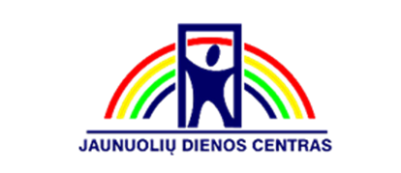
Does your Province, Region or the Government invest in sport? In particular are there funds and open call for the development of sport aimed at people with disabilities (intellectual and physical)?
Panevezys City Municipality offers free use of the bases of the Physical education and sports center bases:
- Ice Arena;
- Swimming pool of "Aukstaitija" sports complex;
- In the small hall of "Aukstaitija" sports complex;
- Basketball hall;
- Handball hall;
- "Nevezis" gym;
- "V. Variakojis" sports complex;
- Athletics manage.
The services are paid for by the municipality.
The information about the facilities: https://panevezys.lt/lt/naujienos/vaikai-senjorai-neigalieji-rqgu.html
Open sport clubs are budgetary institutions funded by the state budget or municipal budgets. There are 9 in total.
Visitors to our institution attend these open sports clubs for free according to a pre-arranged schedule.
There are 104 private sports clubs registered in the city and only one sports club for the disabled "Sauletekis".
Opencalls – https://www.panevezys.lt/lt/veiklos-sritys/sveikatos-apsauga-261/visuomenes-sveikata.html
2019 - INVESTMENT IN SPORTS AT THE LEVEL OF MUNICIPALITY
 | Number of projects submitted by the community | Total amount of funding | Number of projects submitted by people with disabilities | Funding for projects for the disabled
2017 | 42 | 42921,37 euros | 3 | 1300 euros
2018 | 36 | 53989,61 euros | 5 | 900 euros
2019 | 46 | 58356,94 euros | 4 | 2100 euros
https://www.panevezys.lt/lt/veiklos-sritys/sveikatos-apsauga-261/visuomenes-sveikata.html

2019 – Investment in sport at state level
Nationwide The new Lithuanian Sports Law (https://e-seimas.lrs.lt/portal/legalAct/lt/TAD/f585e4e2d85611e8820ea019e5d9ad04?jfwid=-k3id7vg5t) provides funds to be distributed to sports projects through the Sports Support Fund.
Total amount of the Sports Support Fund in 2020 - 13.2 million euros.
These funds are allocated to five areas:
- development, maintenance and repair of sports facilities;
- purchase of sports equipment, organization of sports events;
- to improve the qualifications of sports professionals;
- to promote physical activity.
Projects are to promote the activity and integration of people with disabilities through sport, as well as organizing events, increasing employment, and strengthening communities. Greater involvement of people with disabilities in various active activities is a priority in, therefore, they are for those projects that can ensure this.
 | Funds for sport | Funds for sports for the disabled
2017 | 6 710 643 Euro | 37 517 Euro
2018 | No open data | No open data
2019 | 11 866 000 Euro | 1 187 000 Euro
2020 | 13 535 400 Euro | 1 353 600 Euro

Calls for proposals for sports projects:
http://kksd.lrv.lt/lt/naujienos/skelbiamas-2019-metu-kvietimas-teikti-sporto-projektu-paraiskas
https://www.smm.lt/uploads/lawacts/docs/2064_3639b401fc919e8f68a911f6e5b1360d.docx
https://www.smpf.lt/lt/skelbiamas-2020-metu-kvietimas-teikti-sporto-projektu-paraiskas/
https://www.smm.lt/uploads/documents/Sportas/kvietimas/KVIETIMAS%20(1-4%20sritys).docx

Leading organizations of the Paralympic, Sports Movements of Persons with Visual, Hearing or Movement Disabilities in the Republic of Lithuania:
Lithuanian Blind Sports Federation
Lithuanian Sports Committee for the Deaf
Lithuanian Disabled Sports Federation
Lithuanian Paralympic Committee
Lithuanian Special Olympics Committee
In 2019, the Department of Physical Culture and Sports allocated a total of 785,330 euros to support all these organizations.
https://kksd.lrv.lt/lt/naujienos/dideja-nacionaliniu-sporto-saku-federaciju-ir-neigaliuju-sporto-organizaciju-auksto-meistriskumo-sporto-programu-finansavimas

The Department of Disability Affairs by the Ministry of Social Security and Labor also supports Physical Culture and Sports projects:
Years | Allocated funding | Number of funded projects
2016 | 436 564,25 euros | 79
2017 | 482 794,00 euros | 79
2018 | 545 152,75 euros | 91
2019 | 580 317,25 euros | 83
2020 | 580 584,38 euros | 90

Funding stability is monitored.

http://www.ndt.lt/finansavimo-konkursai/kuno-kulturos-ir-sporto-projektai/skirtas-finansavimas/
http://www.ndt.lt/finansavimo-konkursai/kuno-kulturos-ir-sporto-projektai/projektu-paraisku-teikimas/
http://www.ndt.lt/finansavimo-konkursai/kuno-kulturos-ir-sporto-projektai/
The main funds for their activities Lithuanian disabled sports federations receive from Department of Physical Culture and Sports by the Government of the Republic of Lithuania (hereinafter - DPCS) and from the Department of Disability Affairs by the Ministry of Social Security and Labor (hereinafter - DDA).
Funds for the implementation of sports programs from these departments are allocated every year. Athletes with high athletic achievement receive scholarships to prepare for major international competitions. Funding from DPCS and DDA is insufficient to ensure the systematic training of highly skilled athletes for the European and World Championships and the Paralympic Games, whereas there are insufficient funds for their participation in international competitions and for international tournaments to not only improve the skills of athletes but also to educate the younger generation of athletes with disabilities.
The funds allocated from the state budget are not enough for the systematic training of highly skilled athletes with disabilities for the most important competitions. Municipalities have little support for sports club programs for the disabled. Because the sport for people with disabilities is less attractive to the media, it is difficult to find sponsors.
In Lithuania, the Paralympic movement faces many problems, such as funding, public attitudes, and a lack of qualified professionals. Too little attention is paid to people with physical disabilities, lack of essential facilities and adaptation of the environment. As a result, most disabled high-skill athletes are unable to properly prepare for the Paralympic Games and win Paralympic medals.
There is also a lack of sports clubs in our country that are adapted for people with physical disabilities, as well as qualified coaches and sufficient funding. There are still obviously too few sports clubs for the disabled in Lithuania, and the disabled have better conditions to play sports only in the largest cities of the country. Although funding from the state budget is increasing, the integration of the disabled through sport is hampered by the passive position of municipalities in addressing the most sensitive issues of sports for the disabled – increasing the number of sports clubs for the disabled, financing their programs, and staff remuneration.
Do your associations or other associations dealing with disabilities adopt the integrated approach of sports activities? What kind of experience do you have in the field?
The Youth Day Center focuses on sports activities. Visitors of our institution participate in the following sports activities:
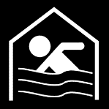 | Swimming in the pool; |  | Exercise with bows;
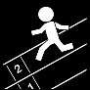 | Running; | 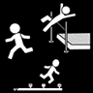 | Athletics training;
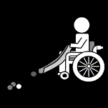 | Boccia; | 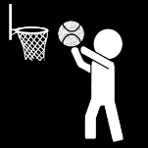 | Basketball;
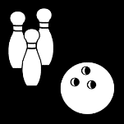 | Bowling; |  | Working with trainers;
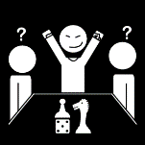 | Chess; |  | Exercise;
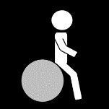 | Exercise with gymnastic balls; |  | Table tennis;
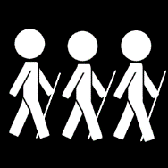 | Walking with Nordic sticks; |  | Aerobics;

 | Zumba; |  | Pilates;
 | Step aerobics; | 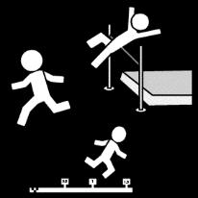 | Athletics in the arena;
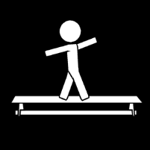 | Body balance exercises; | 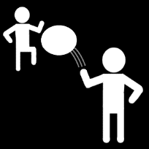 | Throw-catch exercises;
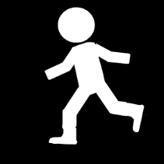 | Body balance exercises; | 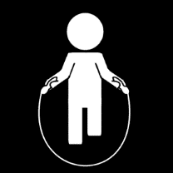 | Jumping exercises;
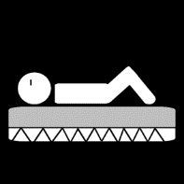 | Relaxation; | 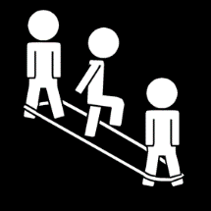 | Jumping exercises;
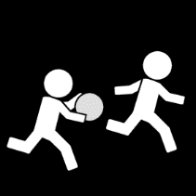 | Ball games; | 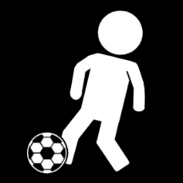 | Ball kicking exercises;
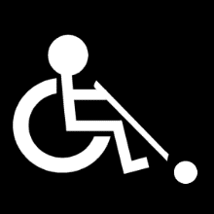 | Adaptation exercises for wheelchairs; | 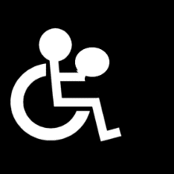 | Exercises with a ball for wheelchairs;
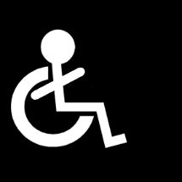 | Yoga for wheelchairs; | 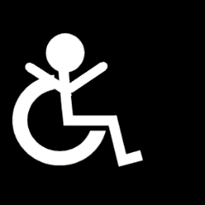 | Exercise for wheelchairs.

Young people visiting our institution take part in various championships and competitions.
Year | Number of competitions participated | Number of participants
2017 | 4 | 45
2018 | 3 | 35
2019 | 4 | 34

We organize various events ourselves, in which we invite the local community and other organizations working with PWD (persons with disabilities) to participate together.
Year | Number of competitions organized | Number of participants
2017 | 2 | 84
2018 | 4 | 81
2019 | 2 | 56

We provide health projects and have been implementing them for many years.
Year | Amount allocated EURO | Number of participants
2017 | 300 | 80
2018 | 100 | 90
2019 | 800 | 100

We work with the following working methods when working with PWD:
- we do not strive for the greatest burdens, wins in competitions, but encourage the joy of movement;
- we encourage the desire to move and choose an interesting form of movement;
- we consistently increase the volume, not the intensity of physical activity, we determine the initial and health-promoting loads;
- we do as many exercises as possible that involve many muscle groups;
- we do more dynamic exercises;
- we combine work with leisure properly;
- we are constantly updating our physical exercises.
Physical activity is organized by adapting it to a PWD and adapting common sports, such as: basketball, volleyball, tennis, table tennis, boccia, swimming, athletics and more.
Usually, day employment centers in Lithuania do not have a sports base and professional coaches. We also face this problem. We play sports in open sports clubs that are funded by state or municipal budgets. Since we don’t have professional trainers, we just try to maintain physical activity. We also do not have the opportunity to play sports in private sports clubs, because the coaches in these clubs do not know how to work with PWD, do not know their strengths and weaknesses, they lack tolerance and there is still a negative public attitude towards a PWD.
How much does JDC integrate into general sports:
- we participate in competitions in general education schools once a year;
- once a year we invite the city community to a sports event we organize.
As the analysis shows, there are very few joint integrated sporting events. Society is often unprepared to accept PWD as equal members. Disability reminds of human vulnerability and intimidates those around them. The biggest problem of society is the inability to look at a PWD objectively, without stigmatization and without prejudice. As a result, we often face the problem of integrating PWD into a healthy society. It is very difficult to invite healthy people to joint sporting events, and even sadder, that we never get an offer from healthy people to participate in joint sporting events.
Other institutions working with PWD also face this problem.
What is the perception of sport conducted by people with disabilities? Is it more / less known compared to the situation of 10-20 years ago?
In post-Soviet times, disability was completely "non-existent". For a long time, the disabled in Lithuania, as in other Soviet republics, were isolated from society: there were no official statistics describing the number of PWD (person with disabilities), their number, detailed information on the demographic, social and economic characteristics of their place of residence, living conditions. The medical model prevailed, when PWD were usually provided with medical and rehabilitation assistance in inpatient closed institutions, they were as if outside public life. Nothing was known about them or they were given a negative social status. During the Soviet era, they were considered unproductive and useless individuals, so there was a tendency to separate them from family, community, and isolate them in inpatient care facilities. There was no talk of any sport and its promotion.
The beginning of sports organized in Lithuania can be considered as 1984-1985, and the pioneers are PWD from Vilnius and Kaunas. The first competition for people with reduced mobility took place on August 18, 1984 in Pasvalys district. The first competition for people with movement disability took place on August 18, 1984 in Pasvalys district. The 34 most active PWD from various Lithuanian cities and districts participated. Prize places were determined by adding up the points of the participants in separate matches (discus, grenade throws, basketball penalty throws, pneumatic shooting, weight lifting and stretching).
1985, December 26, the Republican Sports and Health Club established club for the PWD named "Draugyste". The establishment of the club has intensified the sports activities of the PWD throughout the country. In 1986-1988, the club's branches were established in Vilnius, Kaunas, Klaipeda, Siauliai, Panevezys, Alytus, Ukmerge.
1990, March 11, after the restoration of Lithuania's independence, fundamental changes took place in Lithuanian sports, including the sports of the PWD. A long, difficult and hard process has begun. The legal bases have been reorganized, and medical, social, educational and vocational rehabilitation has been reorganized.
In 1990, an independent Lithuanian Sports Federation for the Disabled (LISF) was established and in 1992 LISF was accepted as a full member of the International Disabled Sports Organization (ISOD), the International Association of Cerebral Palsy and Recreation (CPISRA), and the Stok Mondeville Wheelchair Sports Federation (ISMWSF).
In the first year of work, the "help" of the official founders ended. Only the kindness of individual people, material help and moral support of Lithuanian blind and Lithuanian deaf societies helped to survive, encouraged them to work, to overcome obstacles and failures. All training, competition, methodical and organizational work lies on the shoulders of a group of enthusiasts and activists. Sports competitions for the disabled have been included in the general calendar of sports competitions since 1989.
The healthy also got used to understanding the disabled. After a while, the exercise for the disabled came as no surprise. PWD have learned the sports alphabet.
The Lithuanian Paralympics Committee (LPK) was established in 1990; in 1991 November joined the International and European Paralympics Committees. 1990 The Lithuanian National Olympic Committee became a member of the International Special Olympic Committee. The Lithuanian Deaf Sports Federation was established in January 1991, and on June 25 of the same year, the Kaunas Deaf Sports Club “Tyla” was registered.
In the initial period of sports for the PWD in Lithuania, it became clear which sports are the most popular, the first sports clubs for the PWD were established, and contacts were established with wheelchair basketball teams from other countries. To improve, expand and organize work with the PWD in 1992 a special advisory institution was established - the Lithuanian Disability Council by the Government of the Republic of Lithuania (LIRT). She took care of the implementation of the Law on Social Integration of the Disabled and the establishment of the National Program for the Rehabilitation of the Disabled.
In 1994, a club at the Lithuanian Academy of Physical Education was established in Kaunas by K. Skucas, an active participant in sports for the PWD. It sought to create conditions for PWD not only to play sports but also to include them in normal life. In the same year, Kaunas Disabled Youth Sports Club was established.
Thus, as can be seen, the geography of Lithuanian sports clubs for the PWD and the interest in sports for the disabled gradually expanded.
In recent years, the focus on sports for the PWD has been increasing: sports clubs for the PWD have been established, sports facilities adapted to the needs of the PWD, the competition system is being expanded, thus creating conditions for sports and amateurs, as well as achieving the best results. The victories of Lithuanian representatives in the most important sports events for the PWD are gratifying.
Physical educations, sports for PWD are a means of social integration. There are special schools for the blind and partially sighted, the deaf and hard of hearing, and students with mental disabilities. They offer physical education lessons and intensive after-school exercises. The Lithuanian Sports Federation for the Blind, the Sports Committee for the Deaf, the Sports Federation for the Disabled, the Paralympic Committee and the Special Olympics Committee also work well in Lithuania.
The Lithuanian Special Olympics Committee also has contacts with sports for the PWD. Only these organizations represent Lithuania in international sports organizations for the PWD. The members of the federations consist of 32 sports clubs, which include people with various types of disabilities. More than 3,000 PWD play sports in these clubs.
The social integration system ensures equal opportunities for the PWD to participate in culture, sports and other areas of public life. The social policy of the United Nations and the European Union has, for more than 30 years, recommended that PWD be given equal rights and opportunities to participate in all areas of society, including sport, and denied the inappropriate routine and discriminatory view that PWD are ill and only medical professionals should regulate their physical activity.
Athletes with disabilities believe that participation in sports builds confidence in their abilities. They themselves and those around them who attend events emphasize their ability rather than their inability to do anything. A PWD is proud that there are the same criteria and evaluations for the selection of teams and athletes in sports for the PWD, feels a great appreciation, a respect shown that they can play sports as equal members of society. Despite these optimistic assessments, there are some negative ones:
- formation of prejudices;
- stereotypical thinking;
- contemptuous approach to PWD;
- a neutral position of family members, rather than helping and encouraging a disabled athlete;
- low number of spectators in sports arenas for the PWD;
- various social comparisons and equality in the classification of sports for the PWD.
The PWD understands sport as a multifaceted challenge. The inner desire to make it easier for the best people to play sports is inseparable from the common desire to create barriers and force them to change their social status and lifestyle.
Are there training courses for mixed ability sport? At what level (Association / committees / universities)?
Future professional trainers, in colleges and universities, are not trained to work in institutions with PWD. Sports clubs are afraid of PWD because their knowledge is limited on how to communicate with a person with a mental disability, whatever his physiology is, there is a lack of general knowledge about disability.
Municipal institutions do not provide sufficient financial support for the activities of sports clubs for the disabled. In the country, sports organizations do not create jobs for applied physical activity professionals. Clubs have low-paid sports staff-coaches, sports specialists, instructors. Not all club employees have higher physical education. There is no unified system for involving PWD in sport. There are very few professionals and coaches working with PWD. There are no budgetary institutions organizing sports for the disabled. The main problem of sports for the disabled is that not all Lithuanian cities have staff for coaches, who could train and physically educate the disabled.
There is a lack of specialized training for coaches on how to work with people with intellectual disabilities. Training is funded only for the development of high sportsmanship, after winning a project announced by the Department of Physical Culture and Sports, and it is not available to the regular coach.
Please add any other information you think are relevant to the context analysis.
Summary:
- Lithuanian sports clubs are not friendly to people with intellectual disabilities.
- Professional coaches do not have the knowledge and qualifications to work with people with intellectual disabilities.
- Although support for sports is offered at the state and municipal levels, sports professionals do not include people with intellectual disabilities in their projects.
- Disabled people's organizations do not have sufficient competencies to participate in project sports activities.
- There are not enough non-governmental organizations that can take care of the sports activity of people with intellectual disabilities.
- A person with an intellectual disability is not sufficiently motivated to exercise and take care of their health.
- The opportunity to play sports for a person with an intellectual disability is provided by the main social institutions: care homes, day care centers. Here, sports activities are usually organized by social workers who are not sufficiently qualified.

PWD often face social barriers, and disability leads to negative attitudes and discrimination. They are usually excluded from education, employment and community life, which deprive them of opportunities for their social development, health and well-being. PWD are generally seen as dependent and incapacitated, thus encouraging inactivity, as a result of which persons with physical disabilities often experience limited mobility, as this is not the cause of their disability.
Sport can help reduce stigma and discrimination related to disability, as it can change society's attitudes towards PWD, emphasizing their skills and reducing the tendency to see a disability rather than a person. It is therefore necessary to integrate healthy athletes with PWD. Healthy people, when exercising with PWD, would start to change their attitudes, and at the same time society, by changing their assumptions about what PWD can and cannot do.
Sport is equally profoundly transforming the disabled, giving PWD the opportunity to realize its full potential and sustain change in society. Through sports, PWD gains vital social skills, develops independence, and is empowered to act rather than passively observe life through the window. Sport teaches individuals to communicate effectively, and also emphasizes the importance of teamwork and cooperation and respect for others. Sport is also appropriate for reducing addiction and developing greater independence by helping PWD become stronger both physically and mentally.
Unfortunately, while we understand that from a PWD perspective, sporting activities are most important for improving the quality of life in the areas of communication, enjoyment and satisfaction, and health promotion, we cannot ensure PWD’s full sporting involvement. There is still a lack of understanding and a positive attitude towards a person with a mental disability in our society. Sports clubs are inaccessible due to the lack of training of coaches, the negative attitude of those around. According to the PWD who have the greatest influence on the quality of the sports club's activities, the competence of the manager, the active athletes in the club, sports equipment and the club's budget have the greatest impact.
Talking to relatives of PWD who did not play sports revealed the reasons for not doing sports, that participation in a sports club "worsens the material situation", "problematic arrival to the sports club", "lack of information" and "excessive physical activity". And this is also due to the lack of education of coaches, as many of them do not have higher education. Thus, the motivation to play sports gradually disappears.
PWD attending the Youth Day Center are involved in sports activities. Certain methodologies, sports plans and adapted sports games are developed for them. However, day care centers in Lithuania usually do not have a suitable sports base and professional coaches. Social workers work with PWD, who also lack knowledge related to physical activity, technical exercises, and determination of physical activity. Various international projects help to solve these problems and deepen our knowledge, where we can share good practices with specialists and professional athletes from other countries. From the IDOSPORT project, we hope to learn new working methods by involving PWD as much as possible in sports activities and promoting their development, awareness and independence of athletes.
There are one hundred and three cities in Lithuania and only ten of them have sports clubs for the disabled. The total number is currently 19 sports clubs for the PWD and no sports clubs for people with intellectual disabilities.
http://www.lnsf.lt/klubai/

