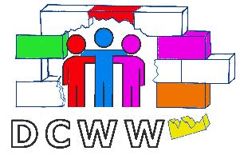 | 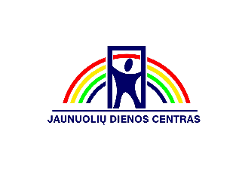
Day Centers Without Walls
No. 2019-1-EL01-KA204-062516

Good practice No 5
Title | Event "Let's meet in the Pine Forest"
Implementation date | 29/06/2021
Institution | Jaunuoliu dienos centras(JDC)
Target audience | Jaunuoliu dienos centras, district community Rozynas and project Focus group
Objective | To destroy stereotypes by offering a cup of coffee to the stranger.
Location /geographical coverages | A. Baranauskas Pine Forest, Rozynas district, Panevezys, Lithuania.
Context
The event "Meeting in the Pine Forest" was organized by the Youth Day Center. During the event, we invited the community to dance together, participate in the Pound sports training, engage in creative and educational activities, discuss, get acquainted with the format of the living library together with young people with disabilities.
Stakeholders and Partners | - Population of Panevezys city  - Rozynas district community  - Youth Day Center PWD  - Project target group
Methodological Approach | Event organization process:  1. An organizational team has been formed:  - Project Focus Group  - JDC staff  2. Shared responsibilities with each other.  3. Was Created program of the event:  - 6 p.m. MUSICAL HELLO  - 6.15 p.m. - Sport - POUND  - 6.30 p.m. FRIENDSHIP TOWER  - 6.45 p.m. FOLK DANCES  - 7 p.m. COLORED PARACHUTES  - 7.15 p.m. Modern DANCES  - 7.30 p.m. FOLK SONGS  - 7.45 p.m. MUSICAL GOODBYE  4.During the event, participants were invited to:  - Participate in the discussion.  - Wear a friendship bracelet.  - Try non-traditional drawing.  - Inflate the largest soap bubble.  - Stay together, communicate and get to know better each other.  5.Participants were informed that the event would be photographed and filmed.  6.After the event, all participants were invited to evaluate the event, express their views, ensuring confidentiality.
Impact
The impact of this good practice is unequivocally positive for the PWD and for the urban community.
The population of Panevezys city and the community of Rozynas district had the opportunity to get acquainted and communicate with PWD in an informal environment. By participating in joint activities, they saw PWD strengths, formed friendly relationships, and broke established stigmas about disability.
PWD acquired new skills in organizing the event, strengthened the sense of responsibility, established friendly relations with the city residents, had the opportunity for self-expression.
Replication Factors and Replicability | We will use this good practice in the future.  We evaluated the positive evaluation results of the event. Community events can become traditional.
Lessons learned | Improve: planning, organizing, communication and collaboration skills, responsibility, self-expression skills, ability to overcome one's fears and broaden one's horizons.
Summary | The event for the city community "Meeting in the Pine Forest" is an example of good practice, the positive impact of which helped to implement the main vision of the DCWW project. The joint activities of the city community with the PWD broke down the borders, breaking the established stereotypes about disability. The PWD had the opportunity to express itself, to make new friendly contacts, and the urban community had the opportunity to test themselves in joint educational activities and to see the powers of the PWD and to change attitudes about communication and collaboration with the PWD.
Contact details | Jaunuoliu dienos centras, Kranto 18  https://www.facebook.com/events/209677314341293
Related resources that have been developed | - Created Leaflets, about the event were and distributed.  - Photos after the event are published on JDC facebook account.  - The created video about the event has been published on the Yotube network, JDC channel https://www.youtube.com/watch?v=3ypDXnQWG3k
Keywords | #DayCentresWithoutWalls  #Erasmusplus  #Epale  #AdultEducation

